**Cognos Bi With Snapchat Ads Data**

**A PROJECT REPORT**

**Submitted by**

**ANUGYA GOYAL**

**19BCG10031**

in partial fulfillment for the award of the degree

of

**BACHELOR OF TECHNOLOGY**

in

**PROGRAM OF STUDY**



SCHOOL OF COMPUTING SCIENCE AND ENGINEERING

**VIT BHOPAL UNIVERSITY**

**KOTHRIKALAN, SEHORE**

**MADHYA PRADESH - 466114**

**LIST OF FIGURES**

| Figure No. | Title | Page No. |
| --- | --- | --- |
| 1 | Introduction | 2 |
| 2 | Purpose | 2 |
|  |  |  |
| 3 | Existing Problem | 3 |
| 4 | Solution | 3 |
| 5 | Images | 4-5 |
| 6 | Conclusion | 5 |

**INTRODUCTION**

In recent years there has been a growing public concern to the amount of personal data that social media sites collect. This data can benefit us as a consumer through targeted advertisement of products. However, it is important that the public are aware of biased ads that may target them.

**PURPOSE**

To create data visualization charts like those mentioned below:

➤ What will be the number of ads in case of Snapchat ads dataset?

Using Snapchat Ads dataset, create a dashboard showing the spend, impression & targeting the audience. Targeting the audience based on the age, interest, segments, language, country or gender. Following are the steps.

➤ In data we have a country ,spend & impression column . So, with the help of these plot a bar chart for showing no. of ads and textual data of country ,spend & impression.  
  
➤ No of Ads by Age group and No of impressions and spendPlot a Bar chart to show the age based on the no of records and also plotting a Bar chart to show the impression and spend ,based on the countries.

**EXISTING PROBLEM**

➤ If we are finding unusual patterns within our data analysis or our statistical significance is not strong enough, we might not have enough data to make valid conclusions.

➤ Without doing data analysis, we won’t get the opportunity to evaluate the data before making actionable plans.

➤ Data is meaningless without context and without context, we cannot turn data into information.

Information is useless without being able to apply to something.

**PROPOSED SOLUTION**

➤ To create various data visualizations using IBM Cognos

➤ To make a dashboard using IBM Cognos

➤ Making dashboards can revolutionize both our success and enjoyment in running our business.

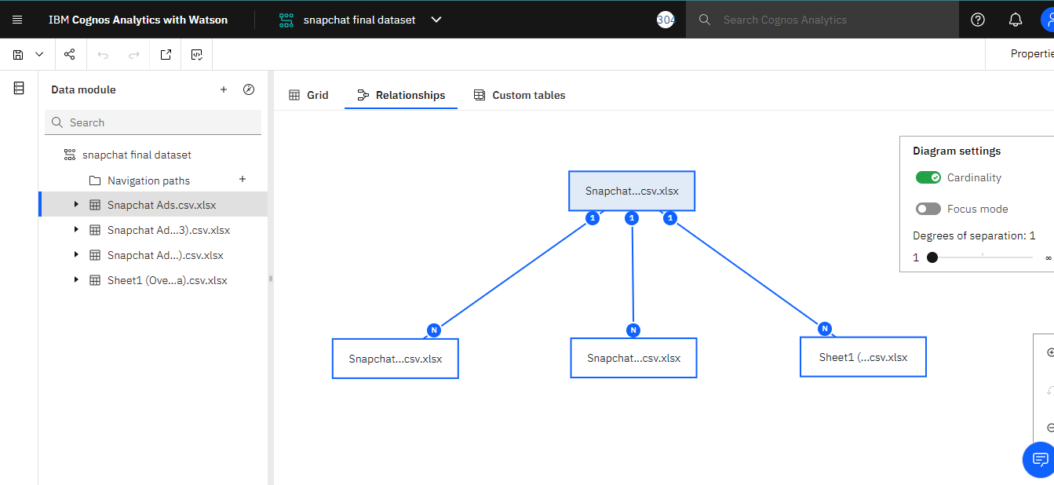

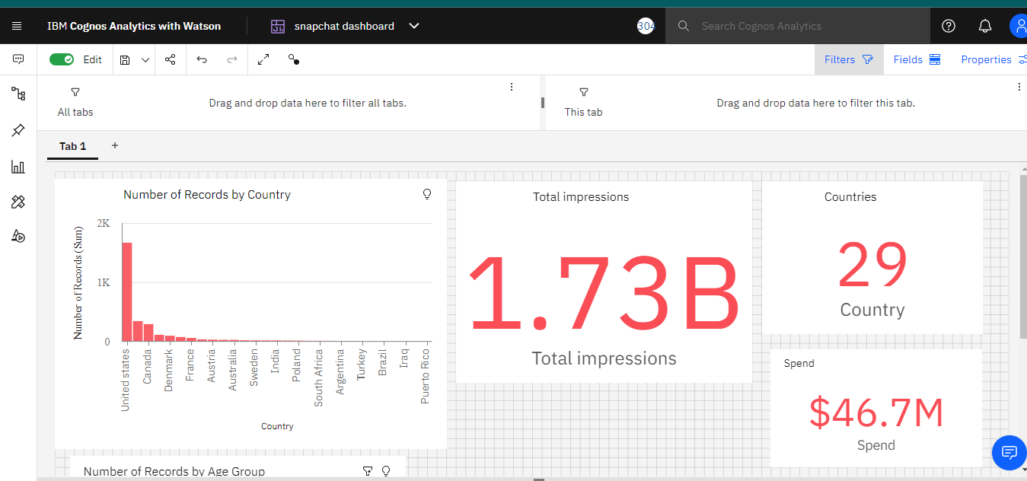

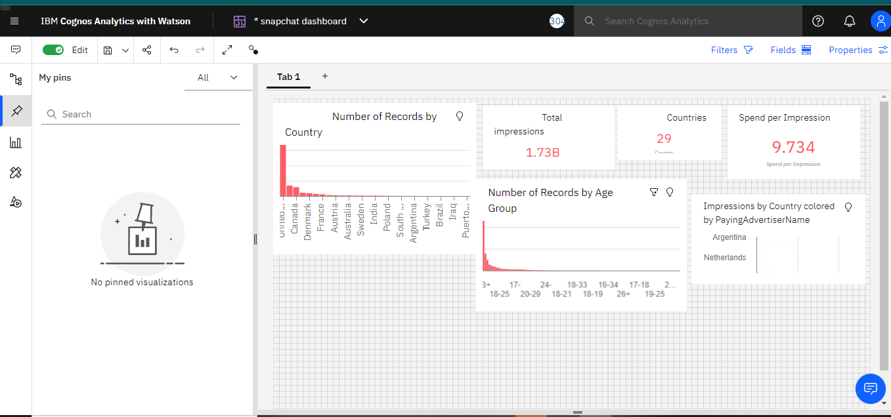

**CONCLUSION**

From this project, we have successfully:

➤ Created multiple analysis charts / graph.

➤ Used the analyzed chart creation of dashboard

Saved and visualized the final dashboard in the IBM Cognos Analytics